**Screenshots for Green's Online Banking System**

**1) Welcome / Sign In:**

Bank users need to sign in to access their bank accounts. Submitting incorrect user name and/or password will result in an error message, while correct input will lead the user to the secured account home.

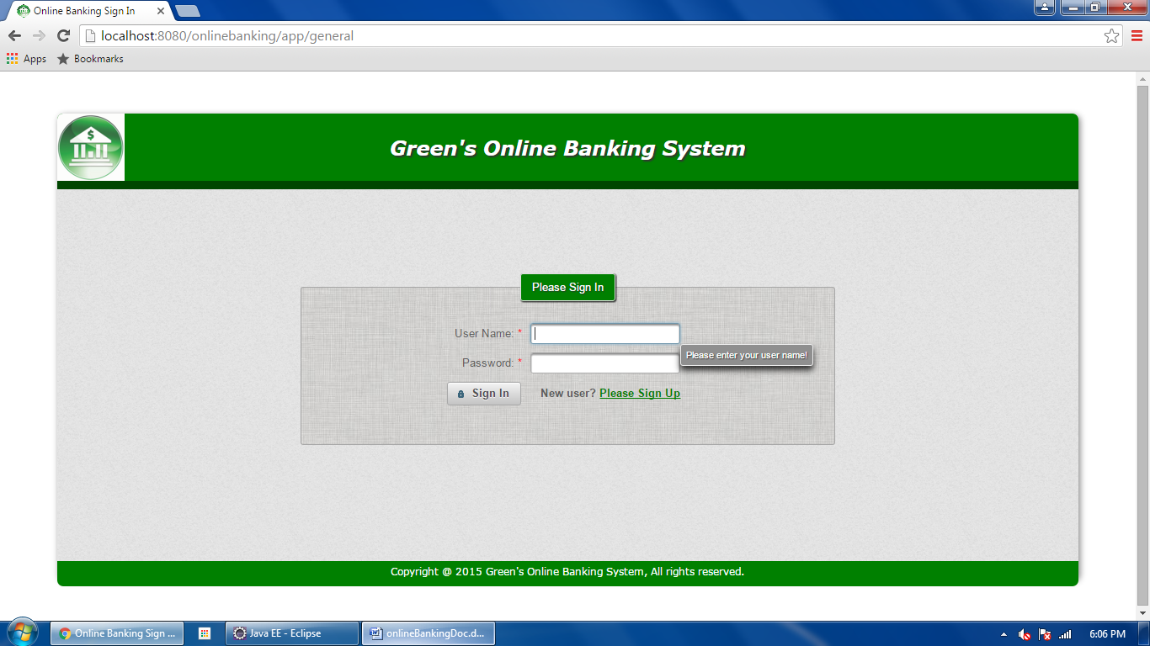

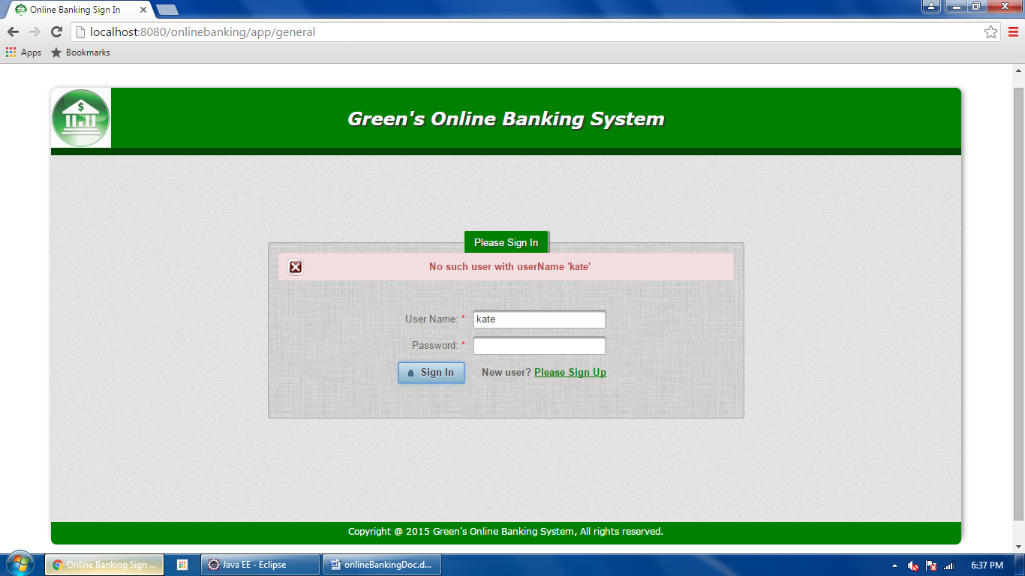

**2) Sign Up**

New users need to register first. The user name must be unique. An Ajax message is displayed to help the user choose a unique username. Submitting information with incorrect format will result in error messages; successful sign-up will navigate the user to his/her secured account home.

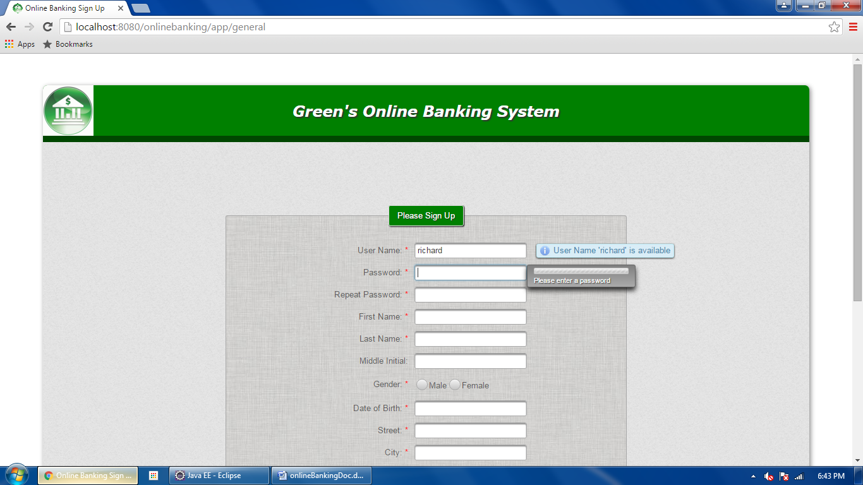

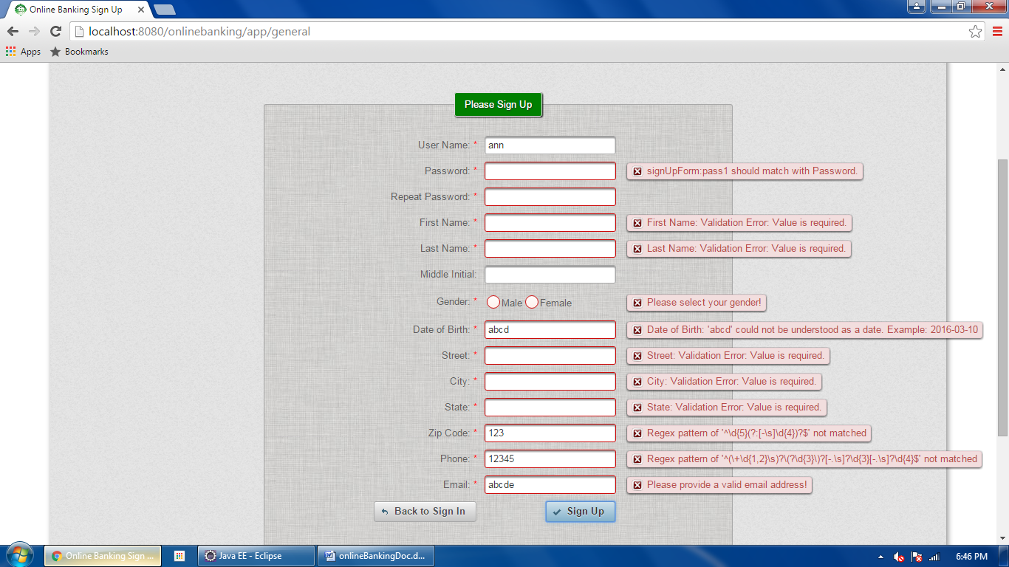

**3) User Account Home**

The secured account home page displays a greeting message with the user's first name. It also has links for the user to update his/her profile and to sign out of this secured account. The information of the user's existing bank accounts are summarized in a table. A column of buttons are displayed on the left for the user to perform bank account related operations, such as add new account, withdraw/deposit/transfer money, and view transaction history. The greeting message and the bank account information table will be updated when the page is reloaded.

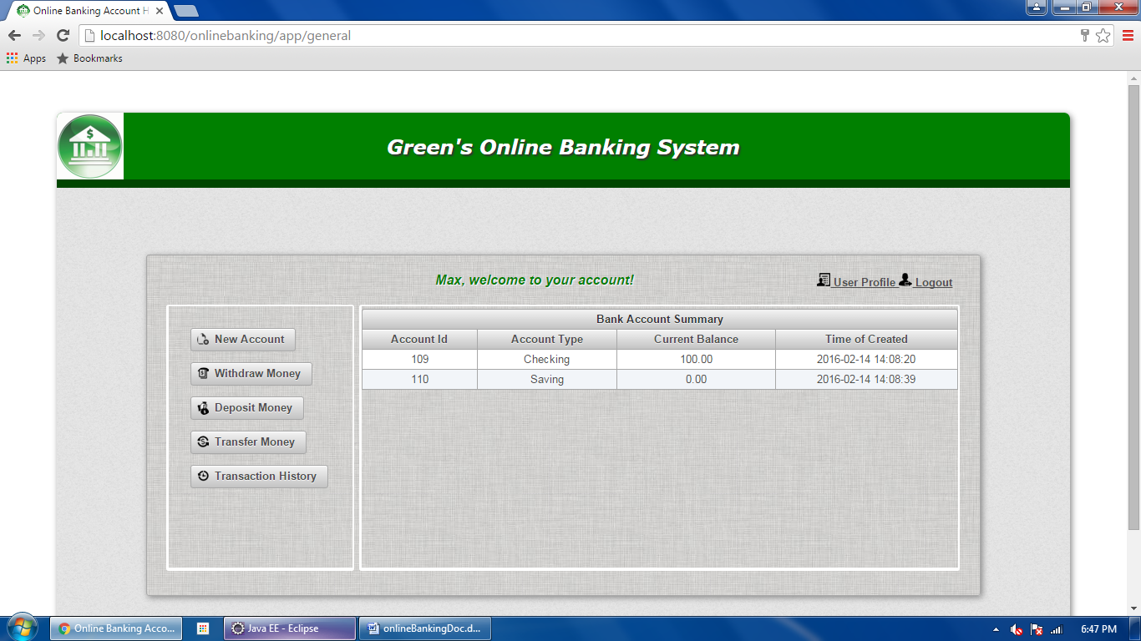

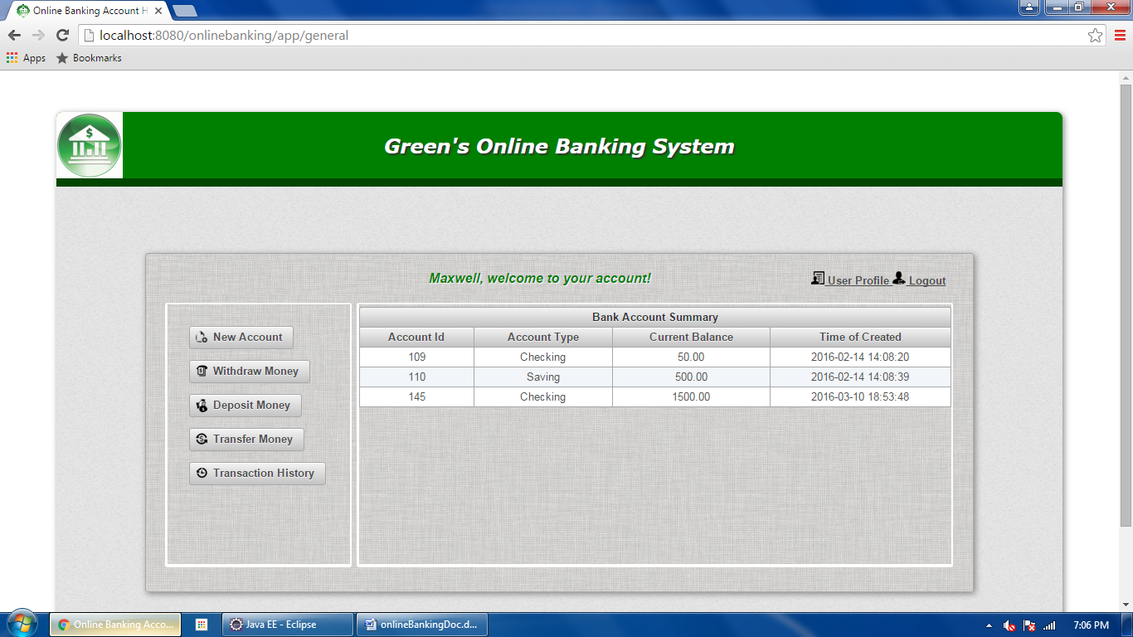

**4) Update User Profile**

User can view or edit his/her personal information through the “User Profile” link in the account home, which will navigate the user to the profile page. The displayed items can be modified when double clicking on them. If update fails, messages are displayed to indicate the cause of the errors; if update is successful, the updated profile is displayed in a new page.

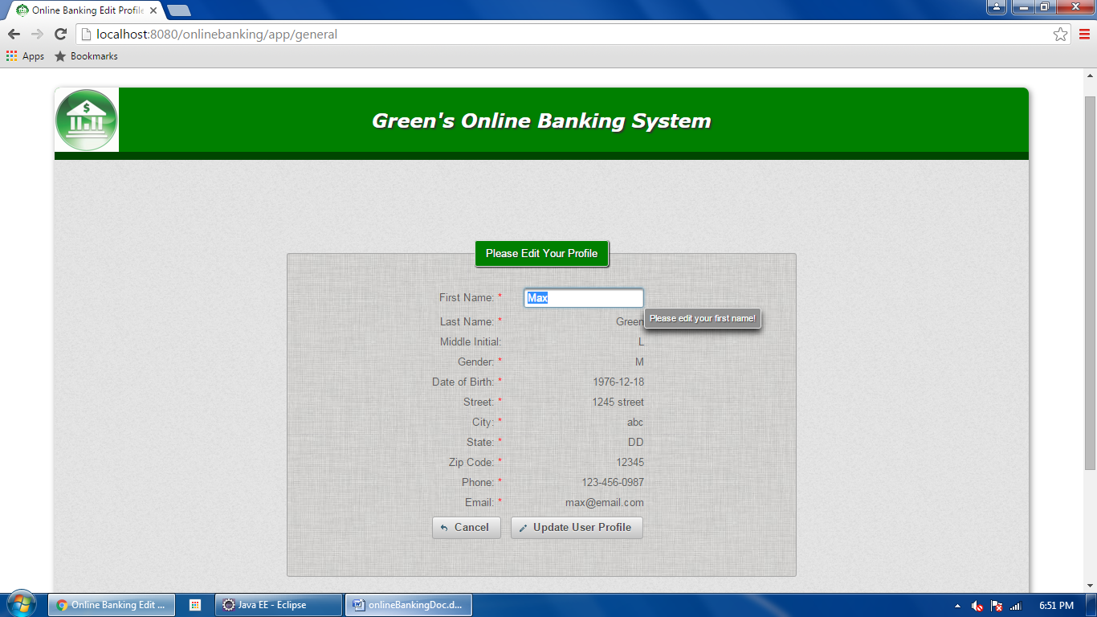

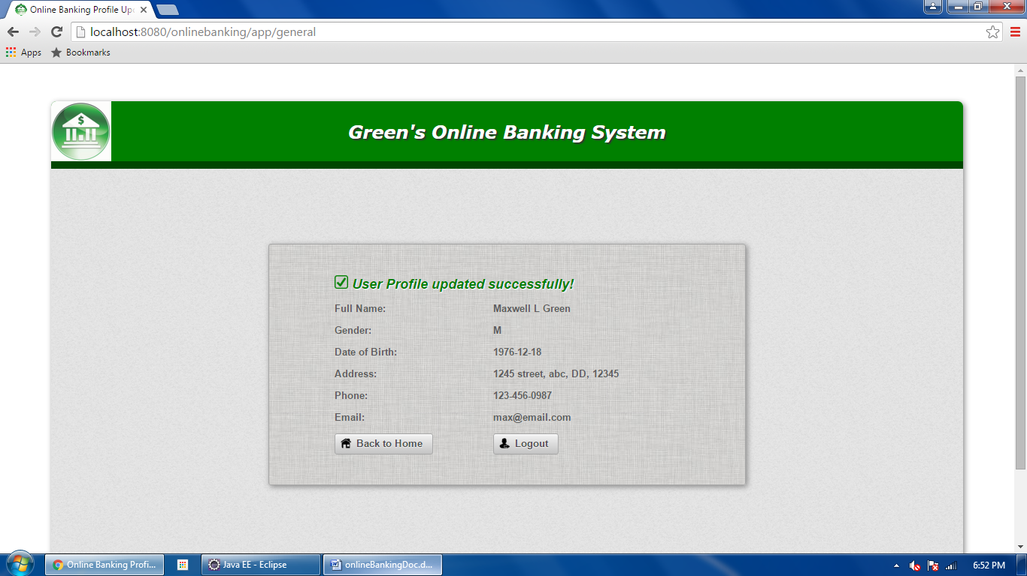

**5) Add New Bank Account**

User can create a new bank account through the “New Account” button in the account home. It will navigate the user to “New Account Detail” page. The user needs to choose an account type and a 4-digit security pin for the new account. The pin is required when performing money transaction from this account. If account creation fails, messages are displayed to indicate the cause of the errors; when creation is successful, the new account information (except the pin) is displayed in a new page.

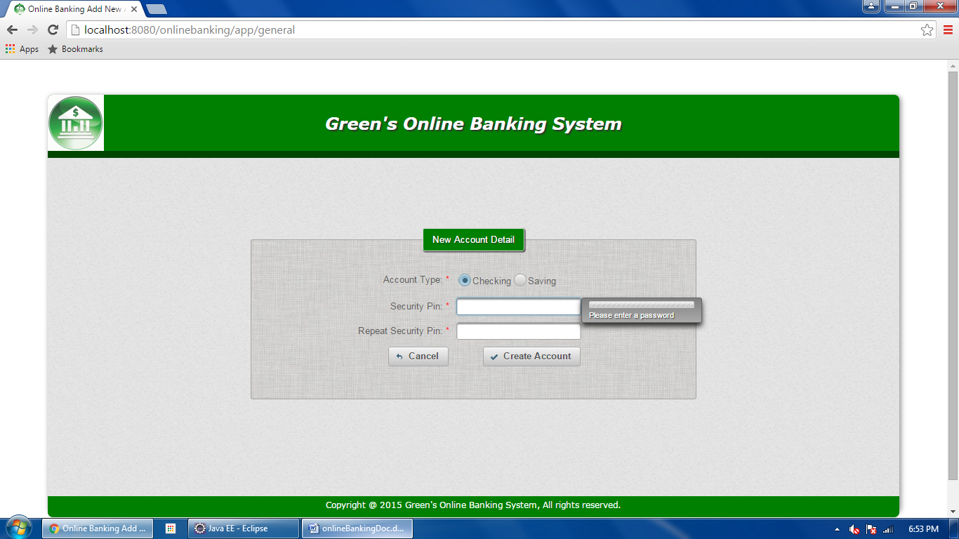

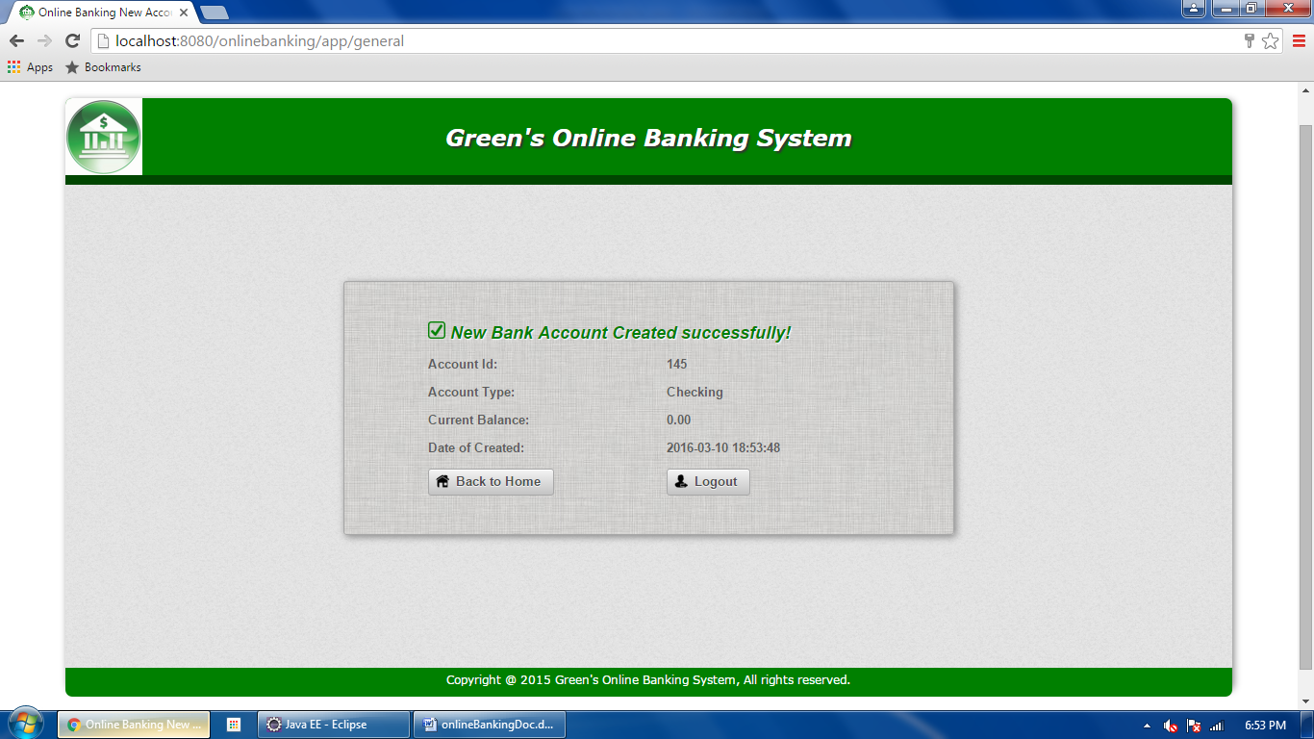

**6) Withdraw Money**

The “Withdraw Money” button in the account home leads the user to the “Withdraw Money” page, where the user can select one of his/her existing accounts to withdraw money from by using a drop-down list. The amount of money to withdraw should be within the limit of that account. The security pin of the account is required. If successful, the withdraw detail will be displayed in a new page. The account balance change will be seen when going back to account home.

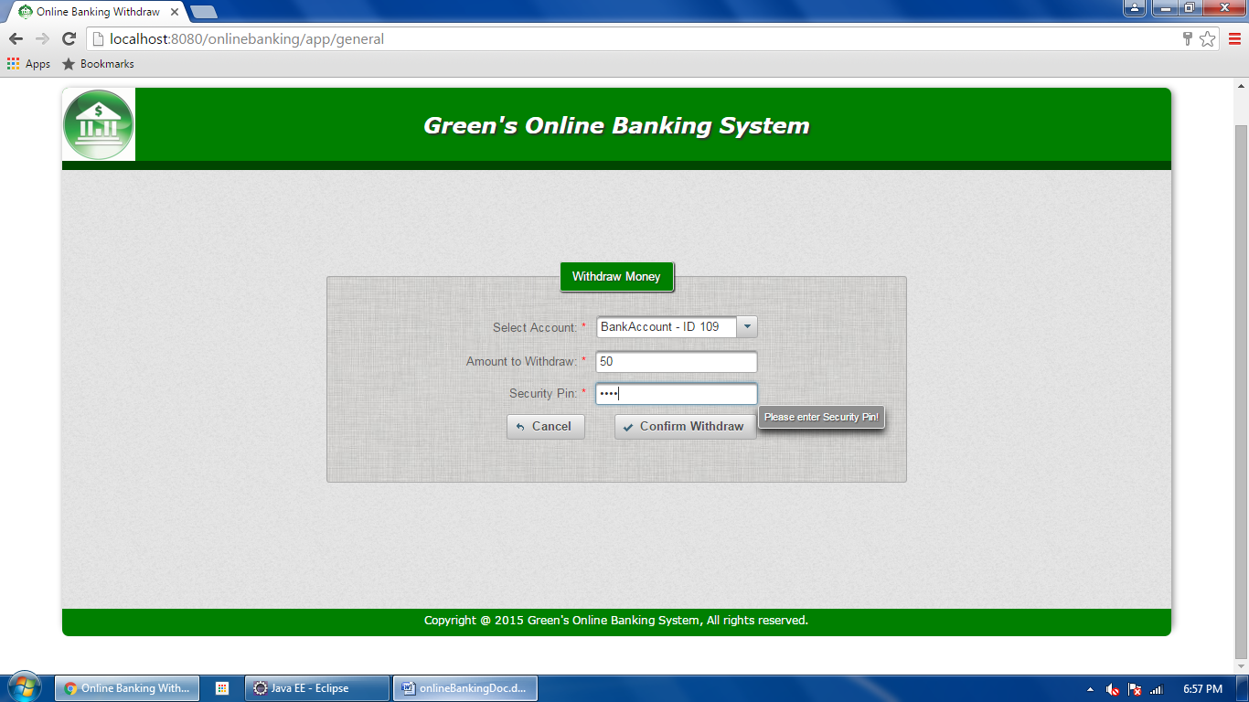

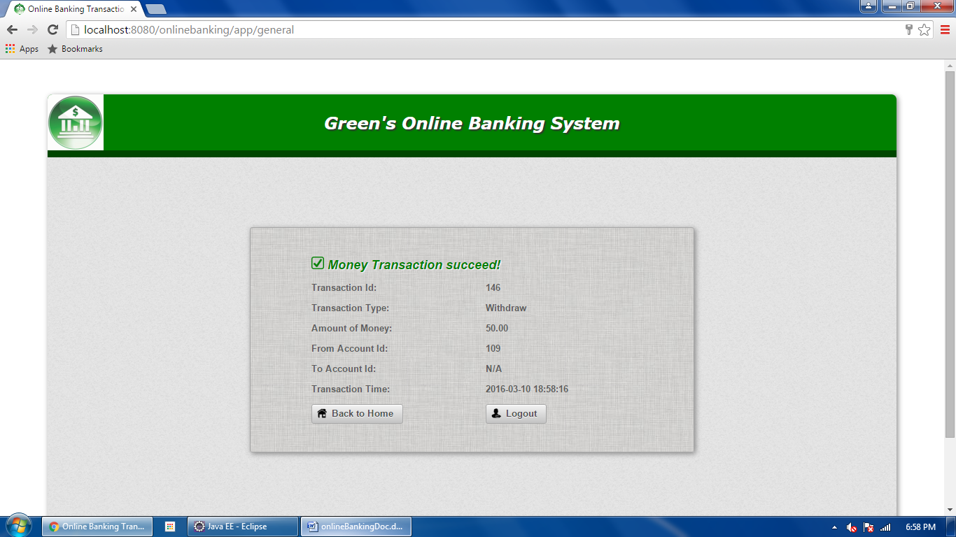

**7) Deposit Money**

The “Deposit Money” button in the account home leads user to the “Deposit Money” page, where the user can select one of his/her existing accounts to deposit money to by using a drop-down list and input the amount of money to deposit. The security pin of the account is required. If successful, the deposit detail will be displayed in a new page. The balance change of the corresponding account will be seen when going back to account home.

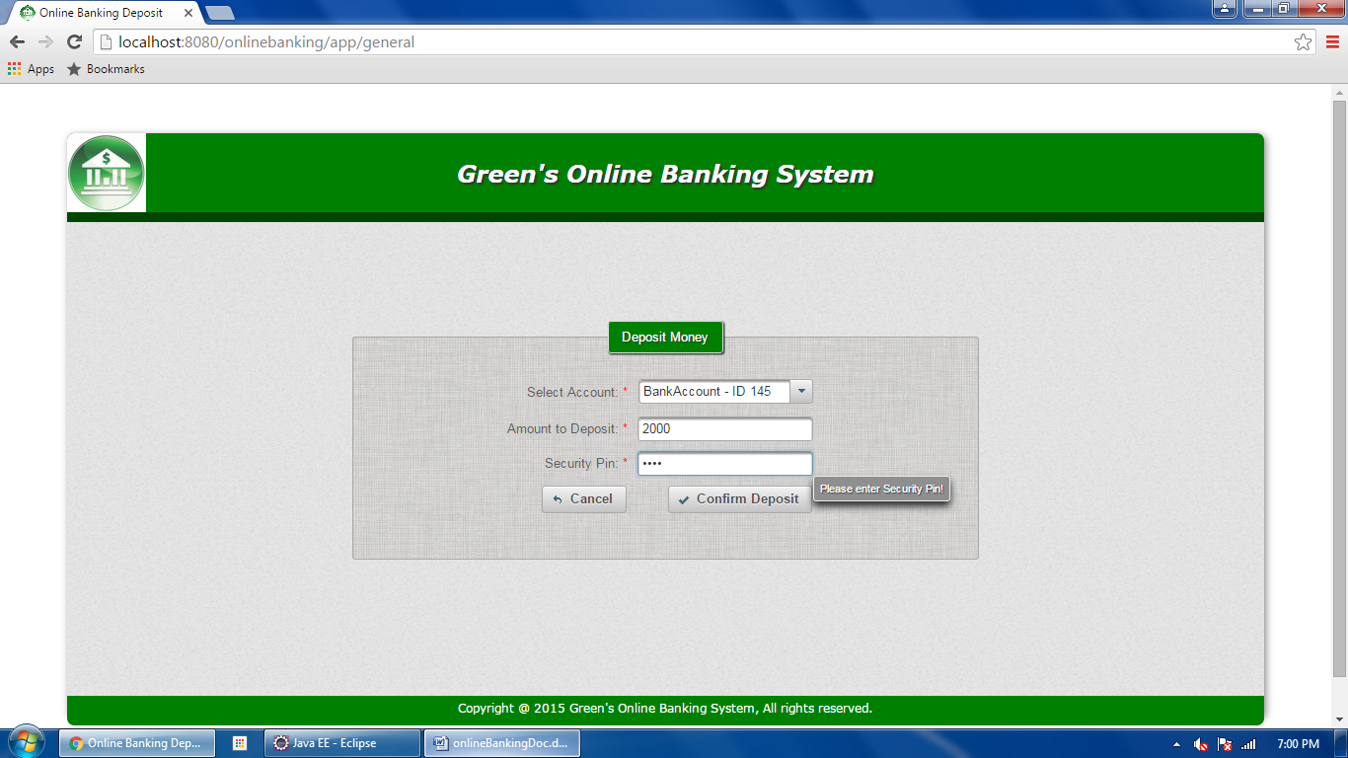

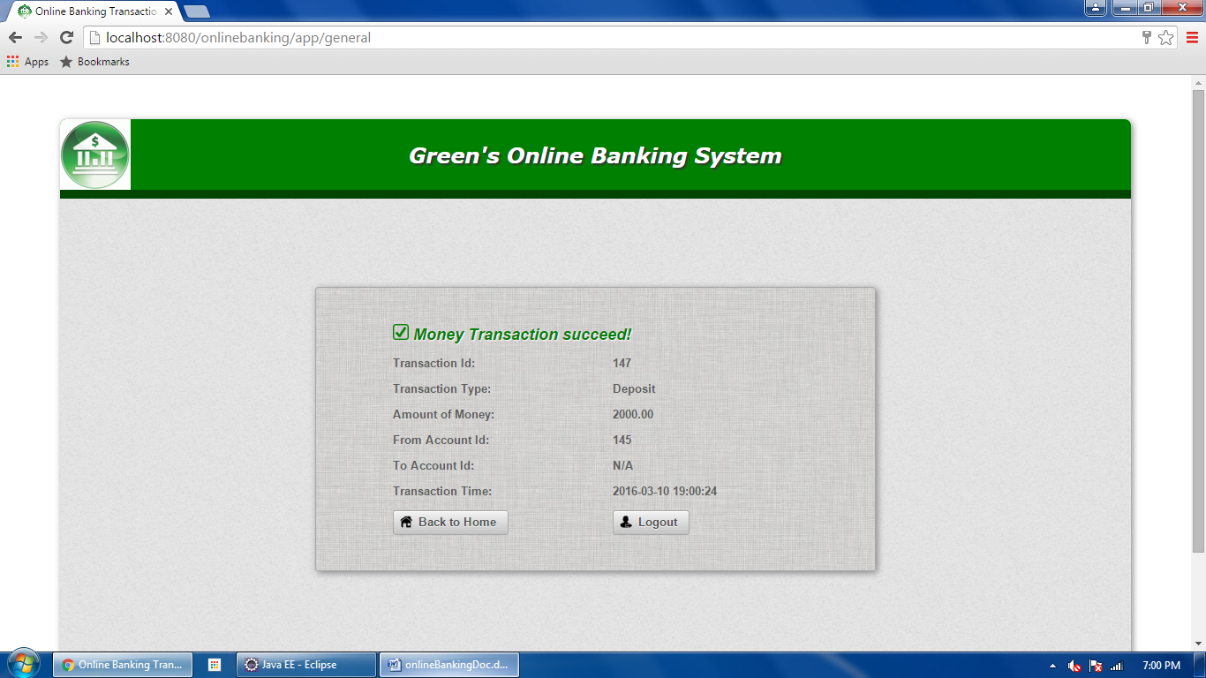

**8) Transfer Money**

User can transfer money from one of his/her existing accounts to any other accounts of the bank system. Within the "Transfer Money" page, the user can select a source account by using the drop-down list; an account id is used for the user to specify the target account, to which money is transferred (an Ajax message checks its existence). The source account security pin is required. If successful, the transfer detail will be displayed in a new page. Account balance changes will be seen in the account home.

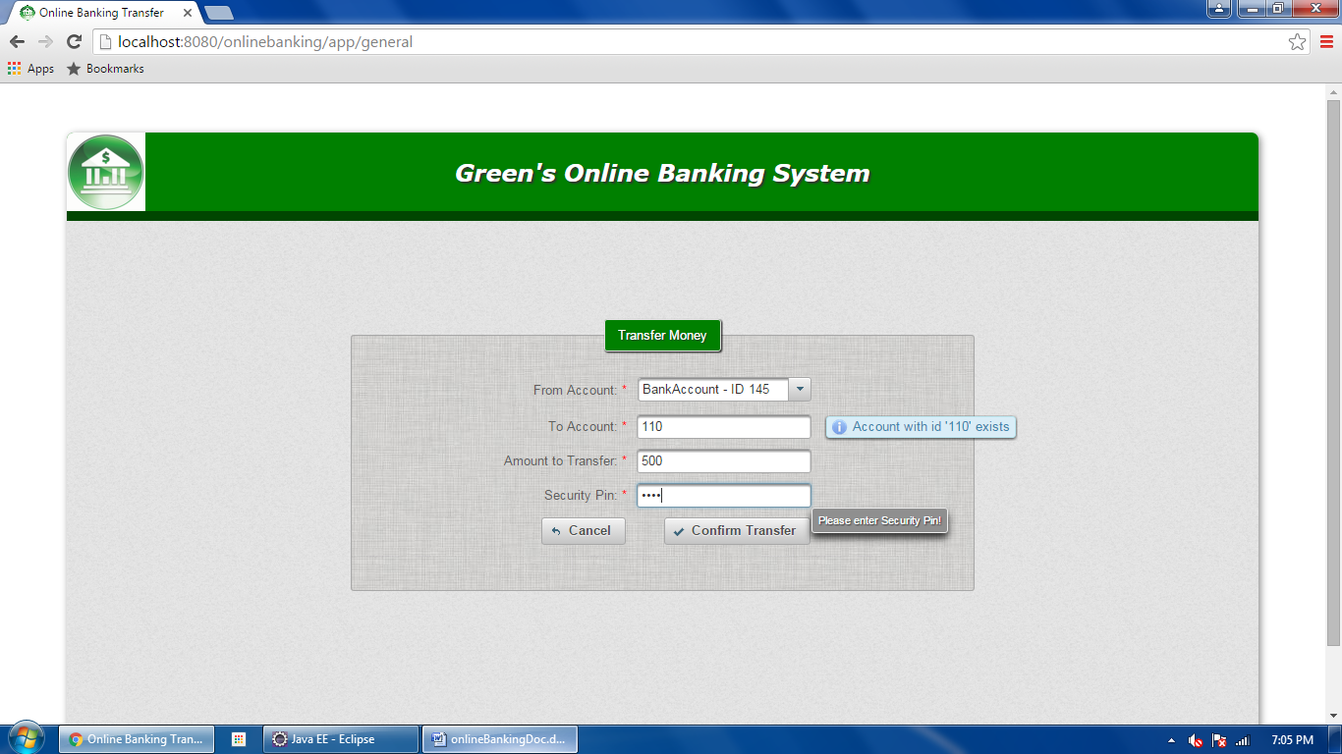

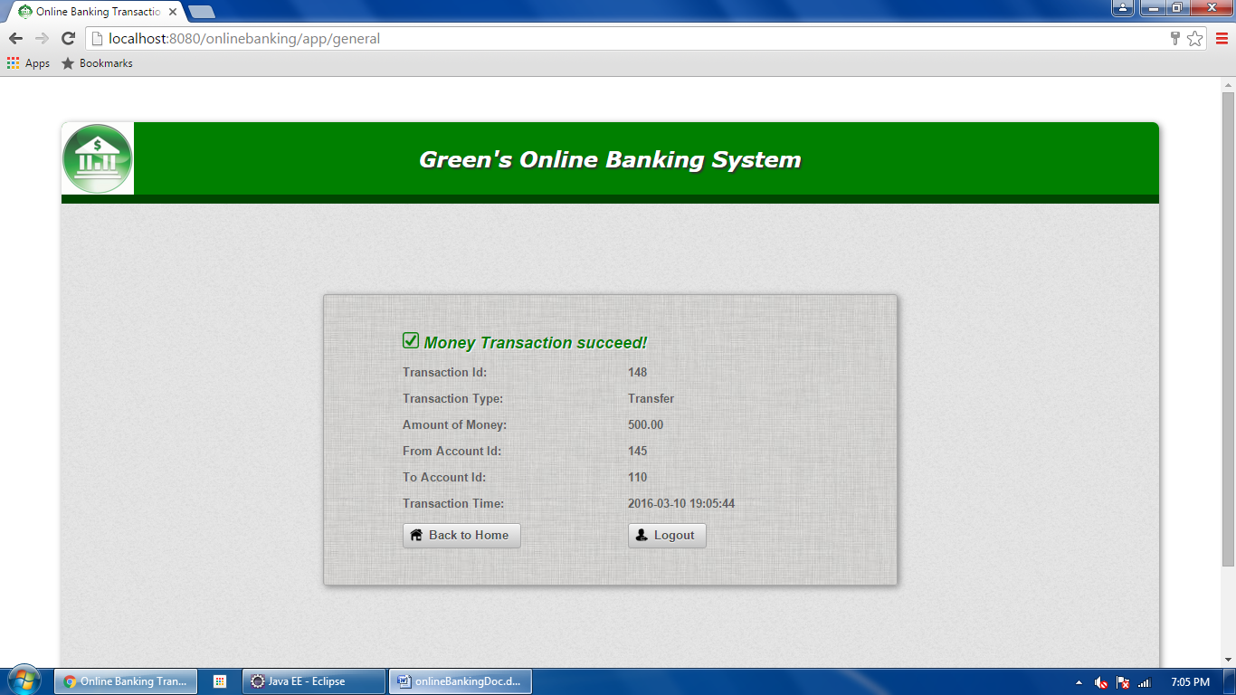

**9) View Transaction History**

User can view transition history by using the “Transaction History” button in the account home. It will lead the user to the “Transaction History” page. The user can specify one of his/her existing account to view by using a drop-down list. The user can also specify the date range to view by using a drop-down calendar. If successful, the transaction records for the chosen bank account within the specified date range will be displayed in a table of the new page.

